Project Title : CRM Application for Jewel management (Developer)

College Name : Vidyasagar College of Arts and Science

College code : bru30

Team ID :NM2025TMID26841

Team Members :

* Team Leader Name – J.Dhivya

E-Mail [-dhivyajagatheesan45@gmail.com](mailto:-dhivyajagatheesan45@gmail.com)

* Team Member1 – K.Dharani

E-Mail [-dharanikanjana8148@gmail.com](mailto:-dharanikanjana8148@gmail.com)

* Team Member2 – R.Gopal

E-Mail –gopalr231026@gmail.com

* Team Member3 – V.Akash

E-Mail –akashkodai12032006@gmail.com

1.Project Overview

The CRM Application for Jewel Management is designed to streamline jewellery business operations. It helps in managing customer details, tracking sales orders, monitoring inventory, and maintaining billing records in an organized way. This application improves customer relationships, reduces manual effort, and supports better decision-making through efficient data handling.

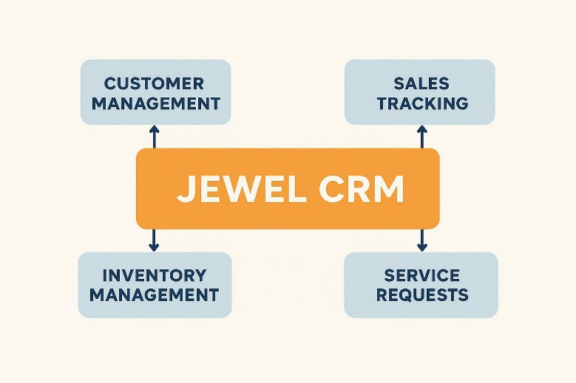

2.Objectives

The CRM Application for Jewel Management aims to improve customer relationships, streamline sales and inventory management, and automate routine tasks. This leads to better customer service, smarter business decisions, and increased efficiency for jewelry businesses.

DEVELOPMENT PHASE

**Creating a Developer Account:**

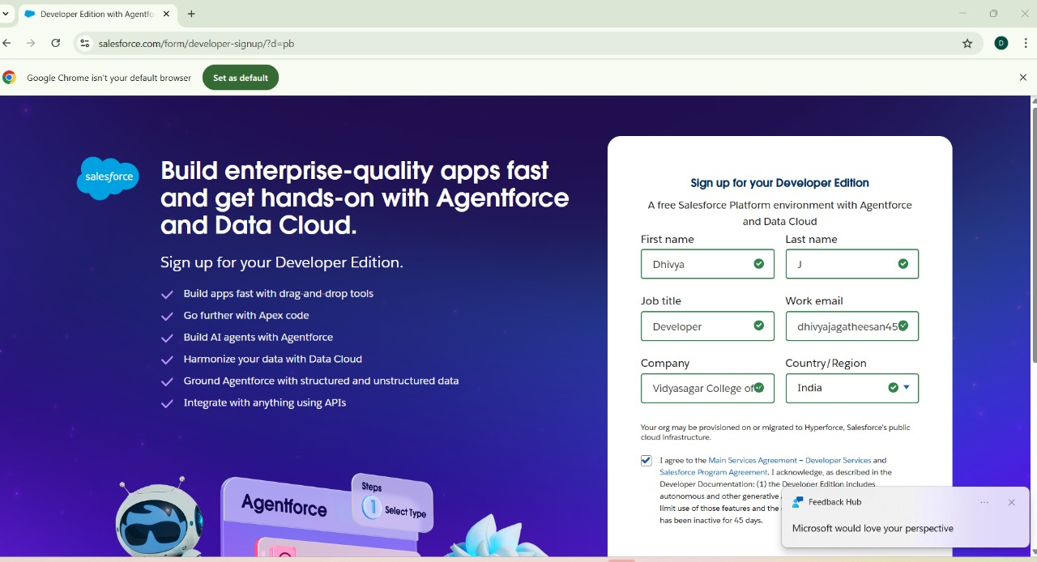By using this URL-https://www.salesforce.com/form/developer-signup/?d=pb

* 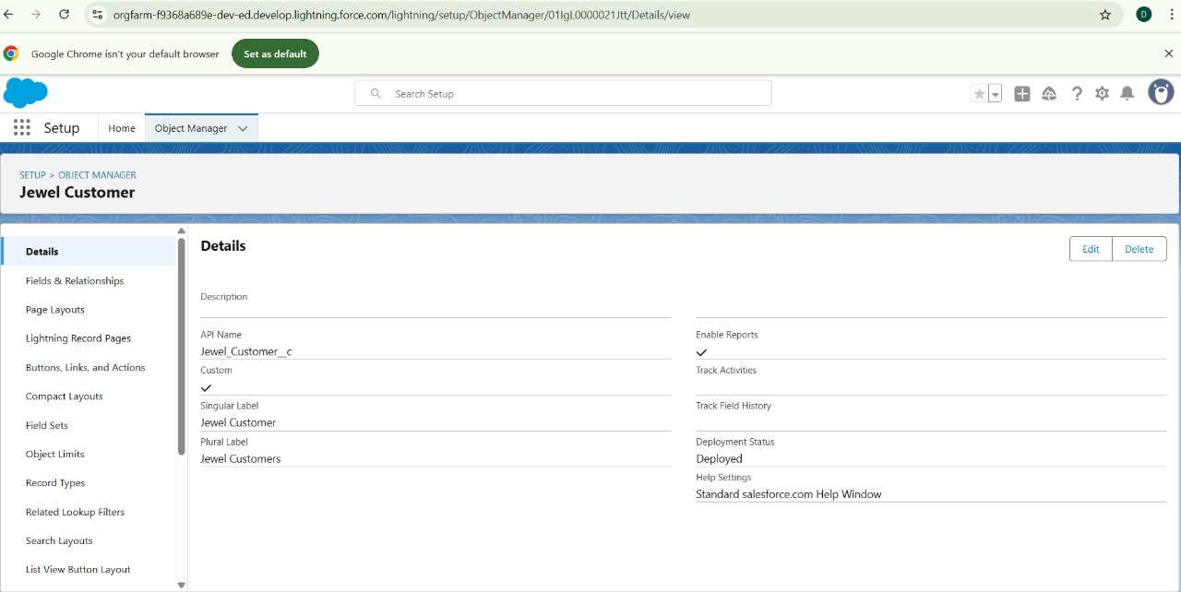**Creating objects** : Jewel Customer, Item, Customer Order,Price,Billings

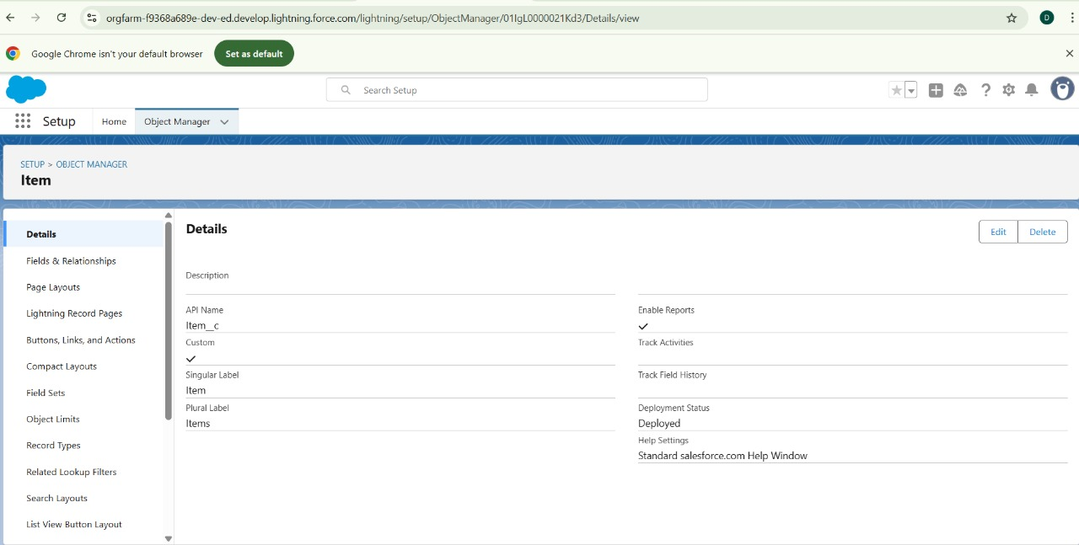

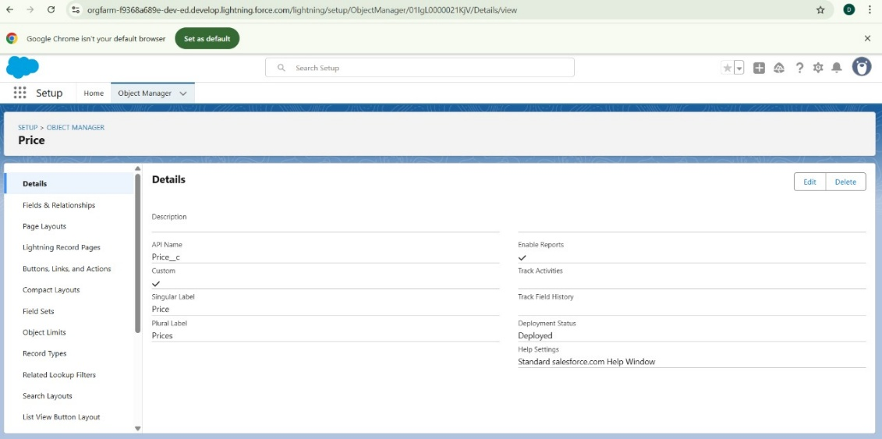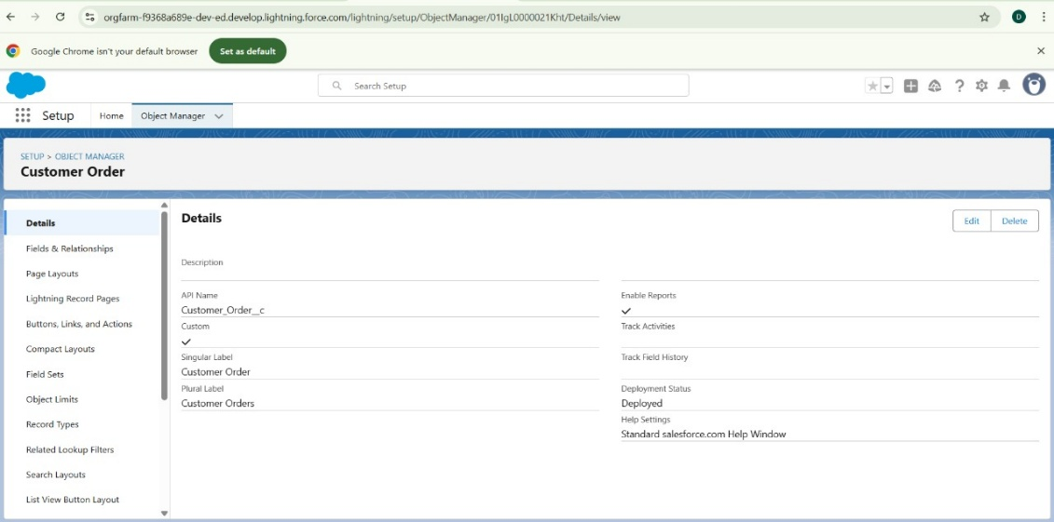

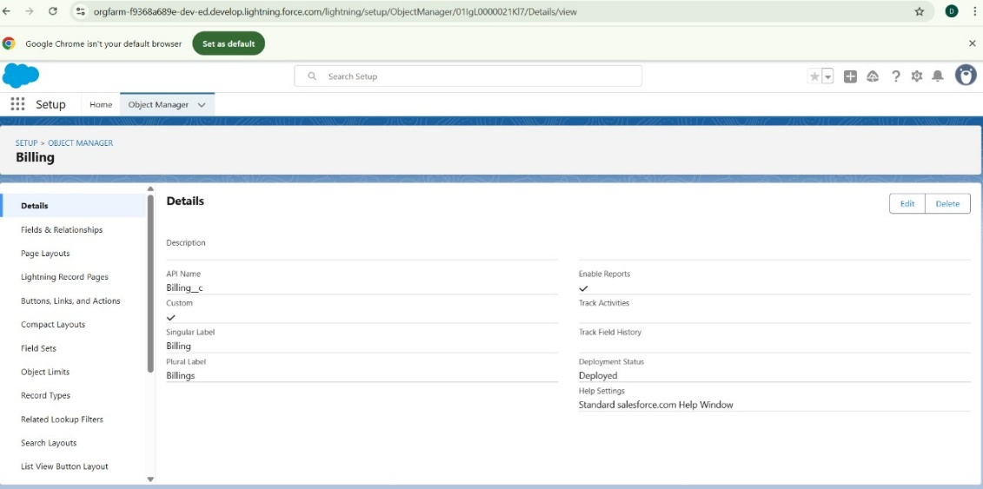

* **Creating Tabs for the Objects:**

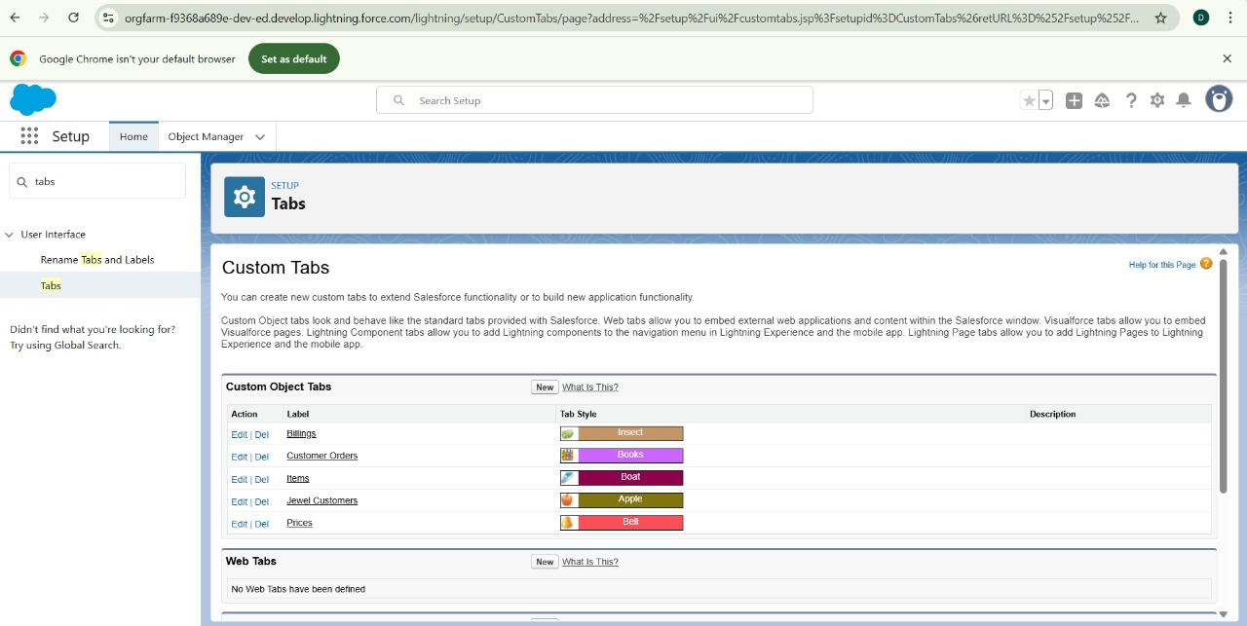

* **Creating a Lightning app:**

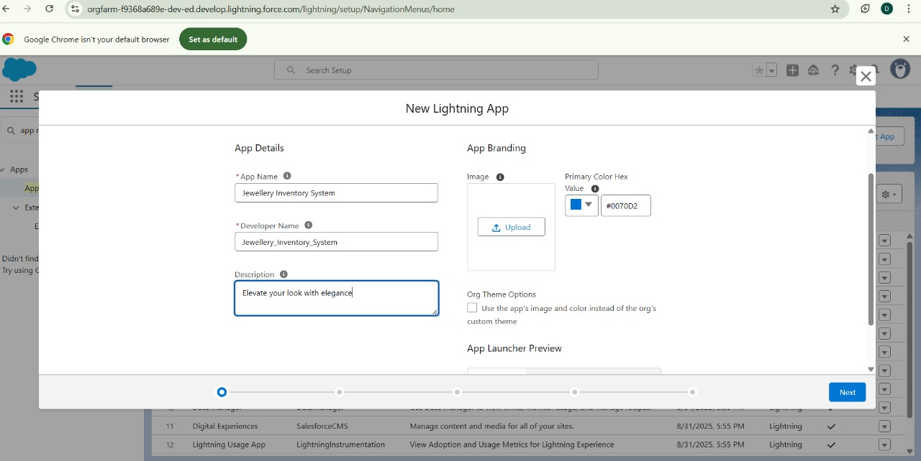

* **Creating Fields and relationships:**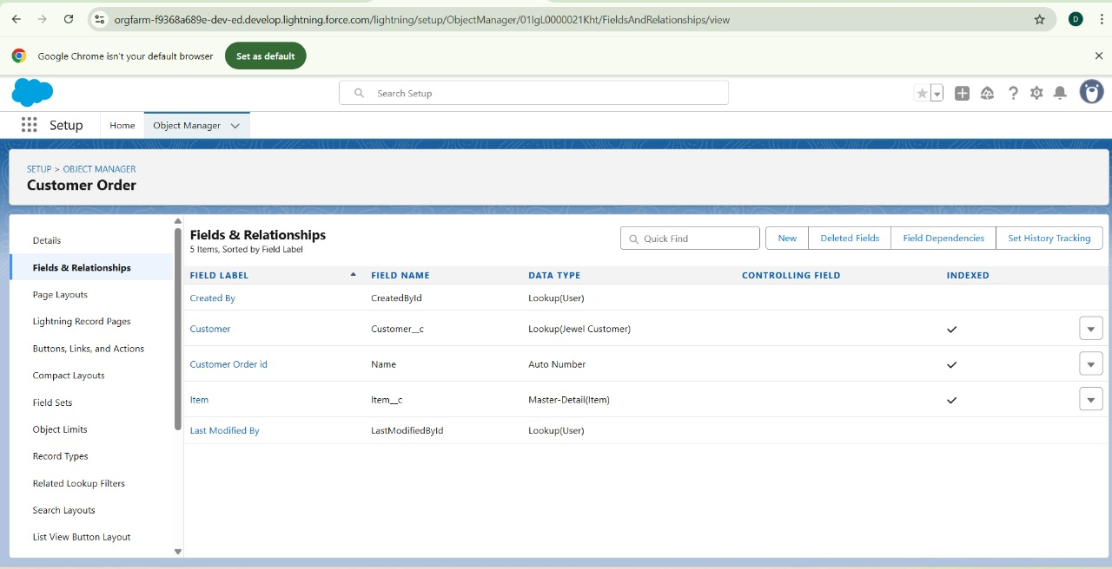

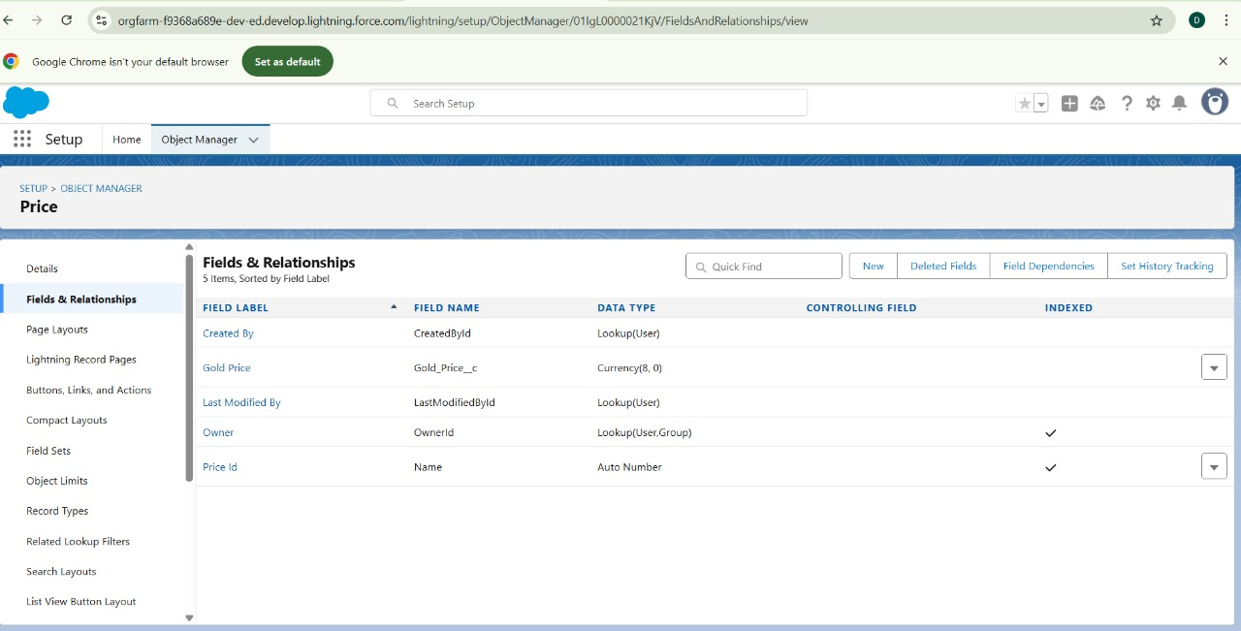

Same for Jewel Customer,Item,Billing

* **Creating the Validation Rule:**

Created Validation Rule for Jewel Customer and Item Objects

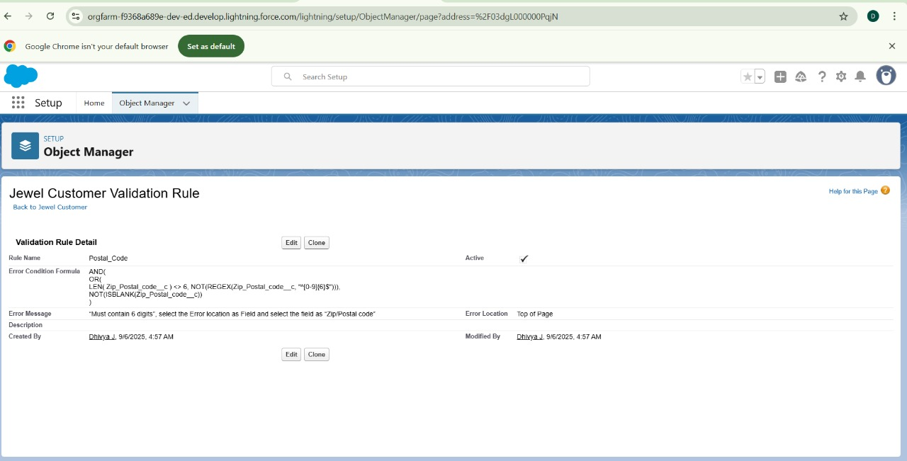

* 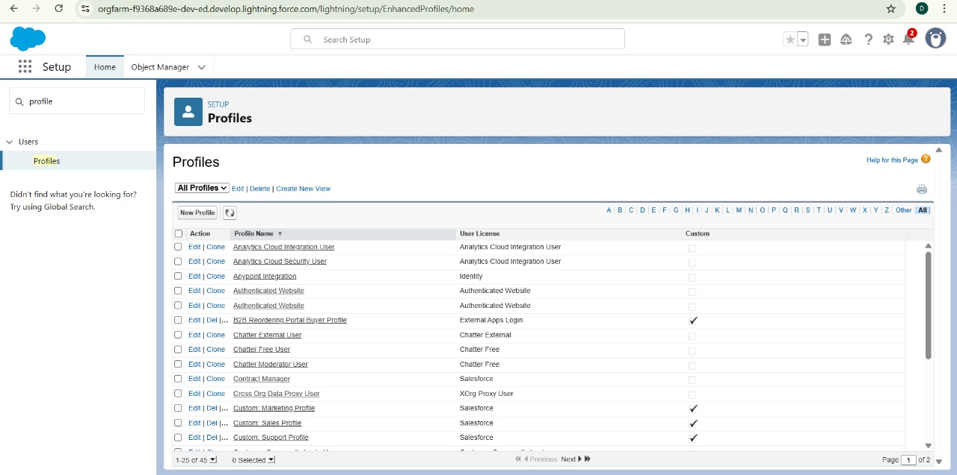**Creating Profiles:**

Created Gold Smith Profile and Worker Profile

* 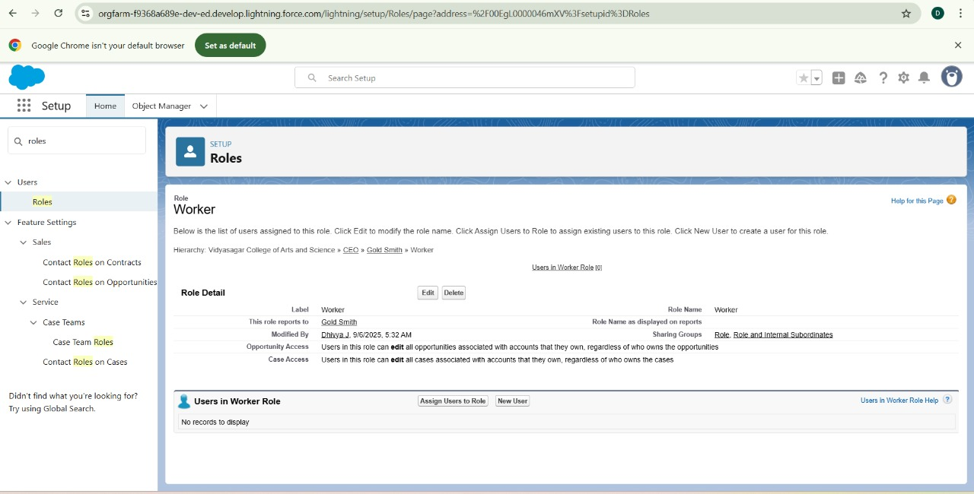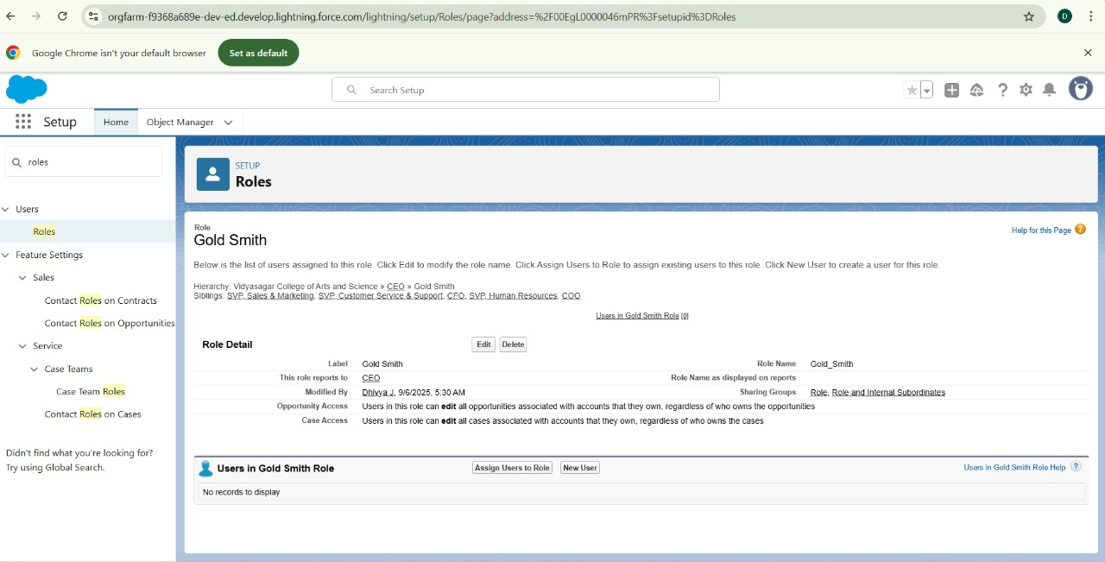**Creating Roles:**

Created Gold Smith Role and one more role as Worker which Reports to Gold Smith

* **Creating Users:**

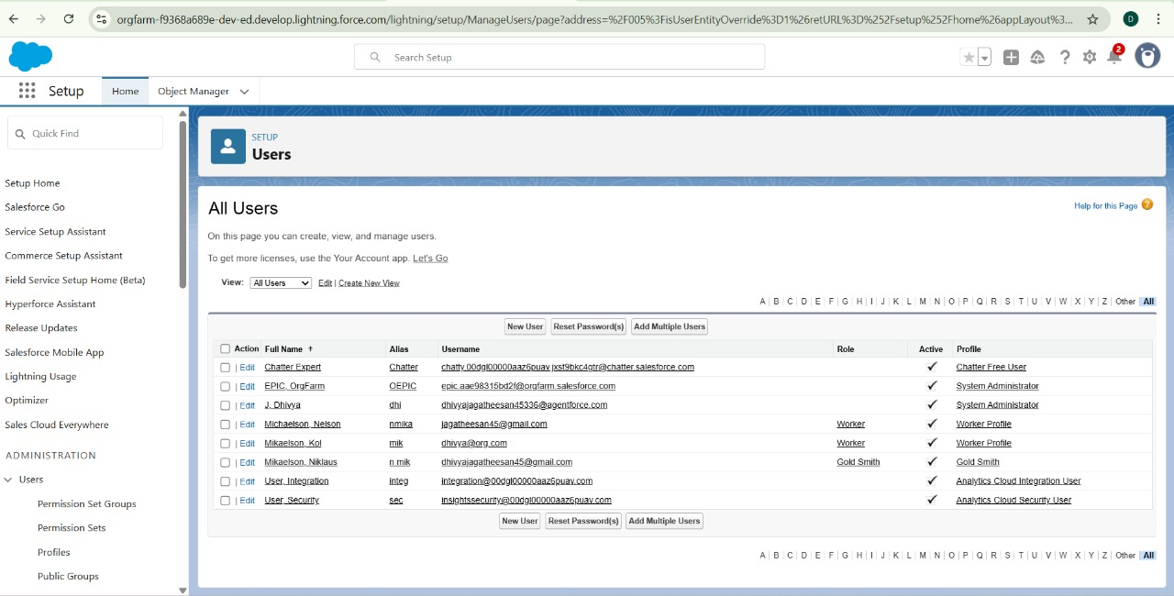Created one Gold Smith Role and two Workers Roles

* **Records:**

Creating Records for Gold and Silver items

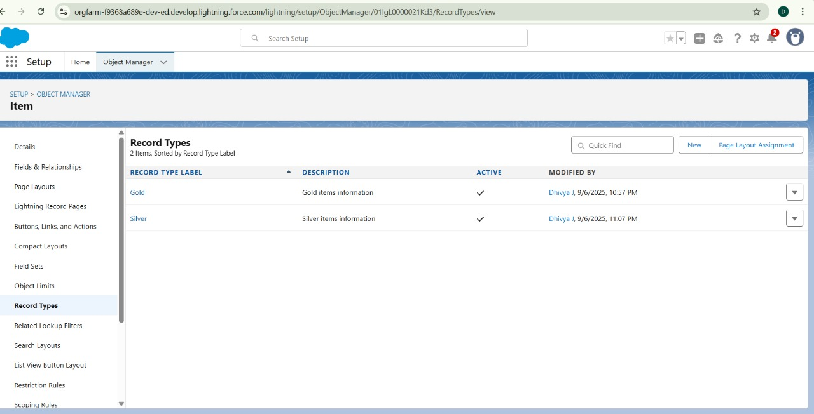

* **Permission Sets :**

Permission sets are used to extend users functional access without changing their profile. Users can have only one profile but, depending on the Salesforce edition, they can have multiple permission sets.

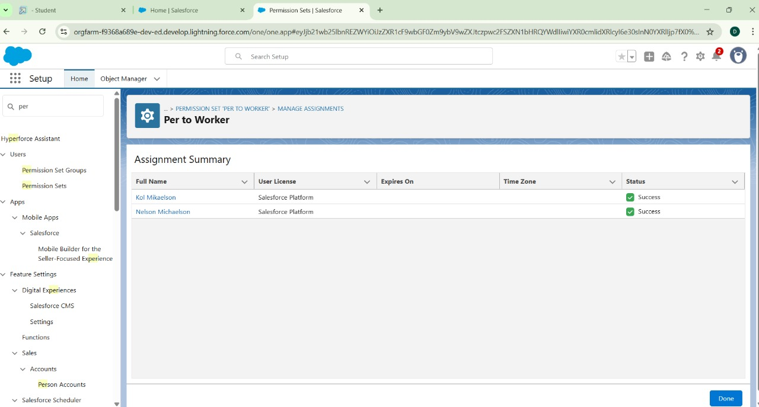

* **Triggers :**

**Apex class Name**-UpdatePaidAmountTriggerHandler

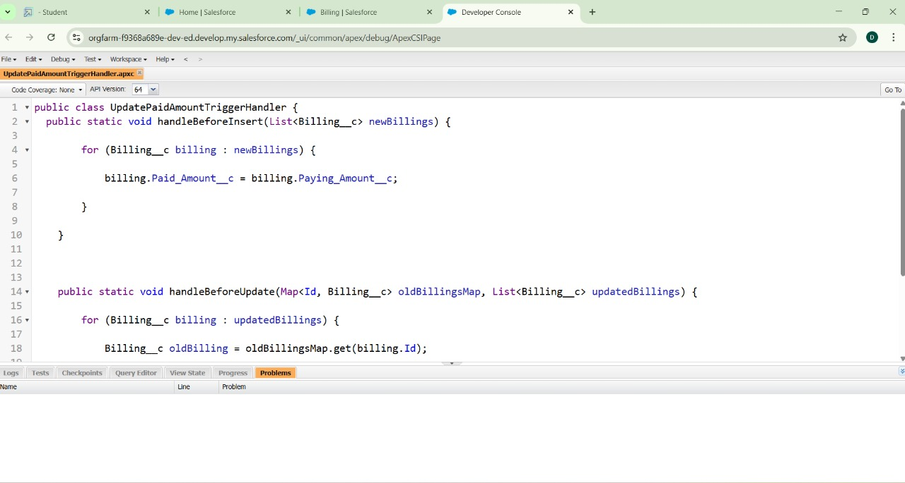

**Created a Apex Trigger:**

**Trigger name**- UpdatePaidAmountTrigger

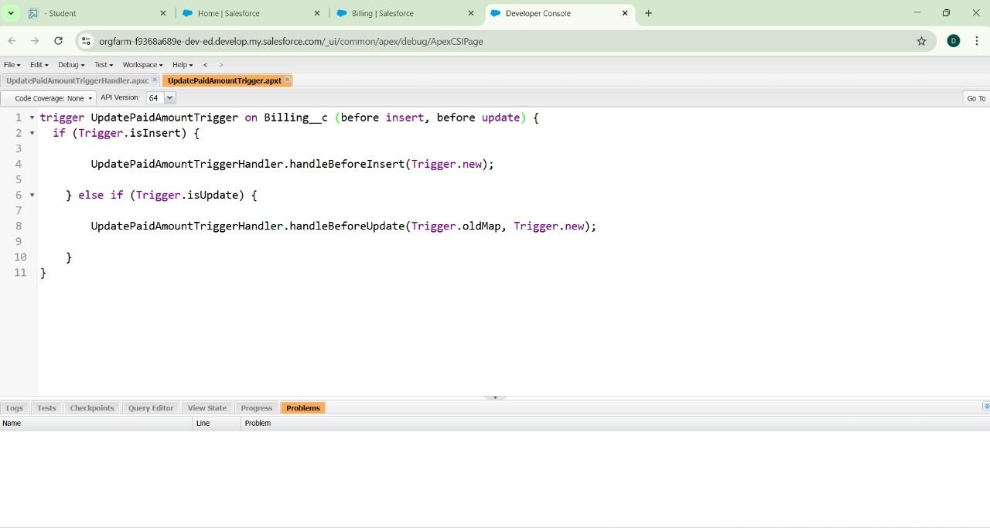

* **User Adoption:**

Creating a Records for Jewel Customer, Item, Price, Billing and Customer Order by clicking on the app launcher and search for jewellery inventory system.

* **Reports:**

Creating reports for Prices, Items with Billings, Billings with Item and Customer Order.

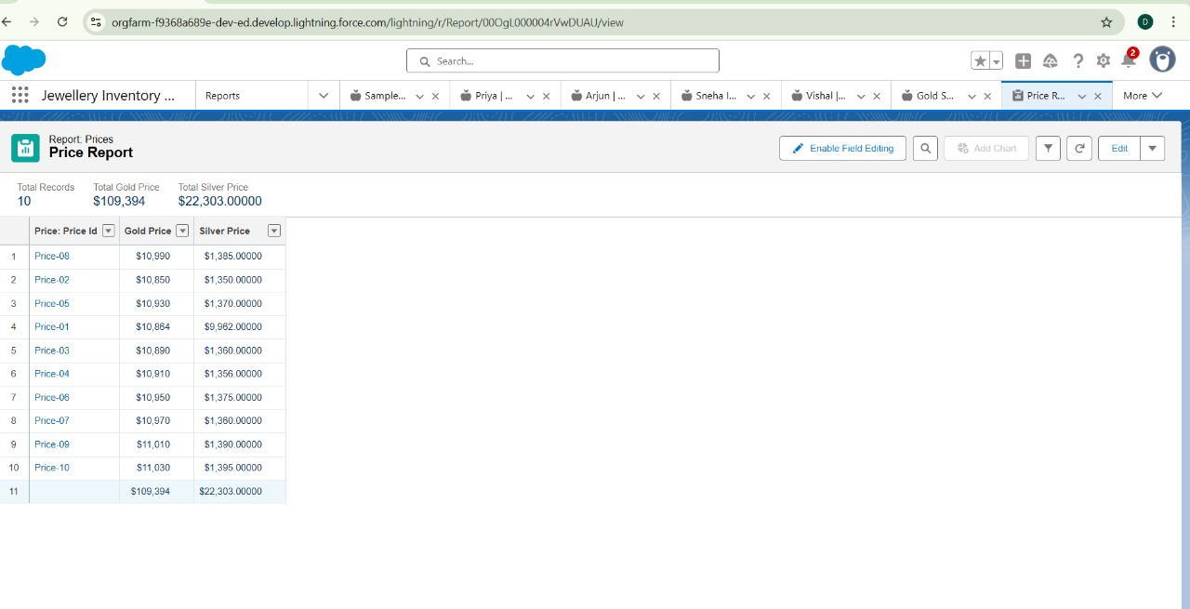

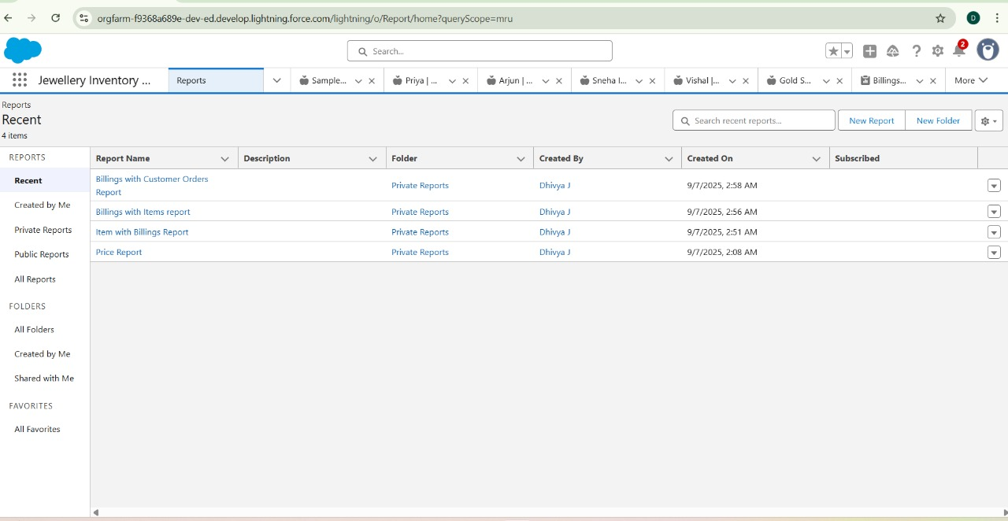

* **Dashboards:**

Dashboards are created by the records of the objects.

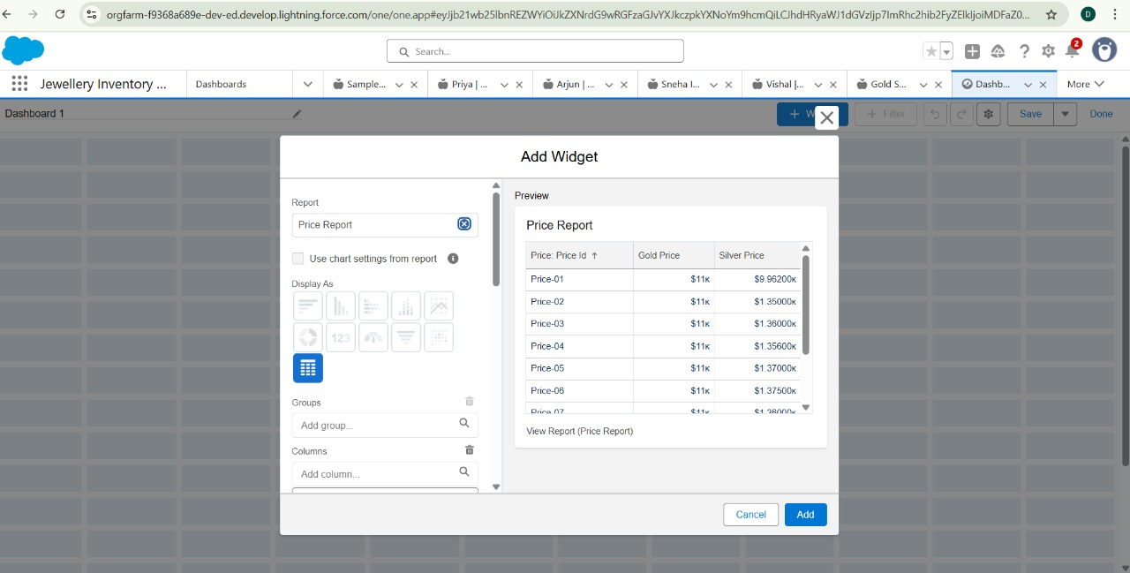

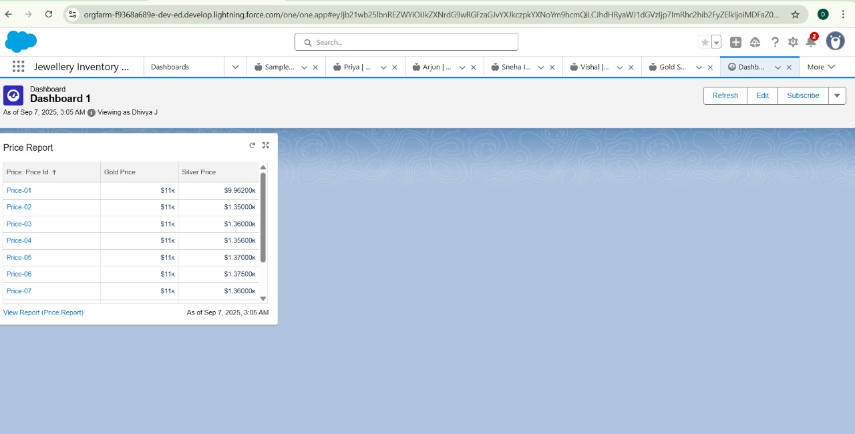

* **Flows:**

A flow is a powerful tool that allows you to automate business processes, collect and update data, and guide users through a series of screens or steps. Flows are built using a visual interface.

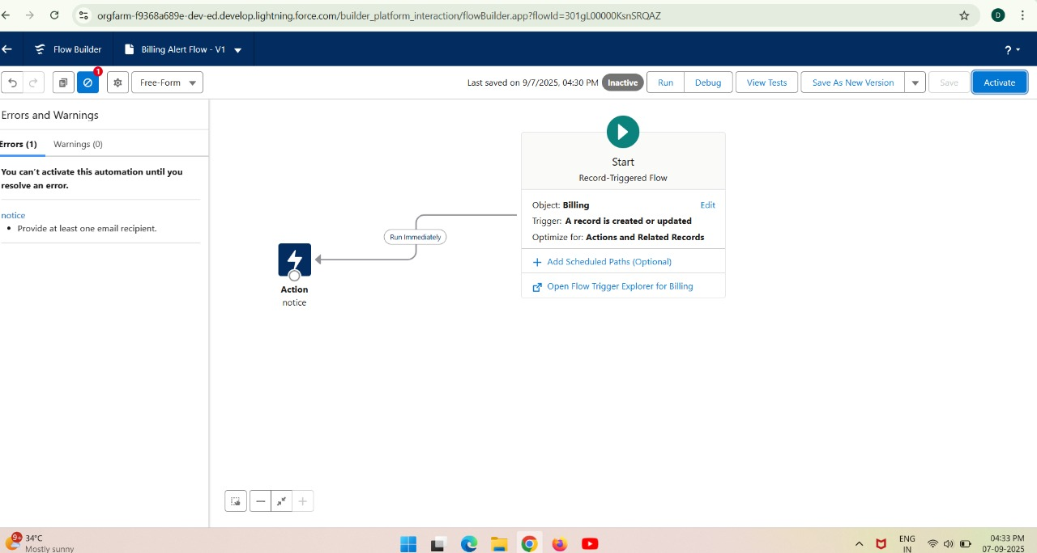

SOURCE CODE

Coding provided in Apex Class and Triggers

**UpdatePaidAmountTriggerHandler.apxt:**

Public class UpdatePaidAmountTriggerHandler {

Public static void handleBeforeInsert(List<Billing__c> newBillings) {

For (Billing__c billing : newBillings) {

Billing.Paid_Amount__c = billing.Paying_Amount__c;

}}

**HandleBeforeUpdate.apxc:**

public static void handleBeforeUpdate(Map<Id, Billing__c> oldBillingsMap, List<Billing__c> updatedBillings) {

        for (Billing__c billing : updatedBillings) {

            Billing__c oldBilling = oldBillingsMap.get(billing.Id);

            Decimal oldPaidAmount = oldBilling.Paid_Amount__c;

            billing.Paid_Amount__c = oldPaidAmount + billing.Paying_Amount__c;

        }

    }

}

**UpdatePaidAmountTrigger.apxc:**

Trigger UpdatePaidAmountTrigger on Billing__c (before insert, before update) {

If (Trigger.isInsert) {

UpdatePaidAmountTriggerHandler.handleBeforeInsert(Trigger.new);

} else if (Trigger.isUpdate) {

UpdatePaidAmountTriggerHandler.handleBeforeUpdate(Trigger.oldMap, Trigger.new);

}}

ADVANTAGES OF CRM JEWEL MANAGEMENT

1.Automatic live gold/silver price updates for accurate billing.

2. Tracks pledged/mortgaged ornaments with due dates and interest.

3.Maintains stone details (weight, type, cost) and custom design catalogues.

4.Generates transparent bills showing purity %, stone weight, and extra charges.

5.Manages warranty, polishing, and after-sale services for jewelry.

6.Handles bulk wedding or ceremonial orders with special workflows.

7. Provides multi-branch access to customer and inventory data.

8. Builds stronger trust with customers through detailed transaction history.

DISADVANTAGES OF CRM JEWEL MANAGEMENT

1.Over-customization for jewel-specific needs may complicate the system.

2.Failure in fetching live gold/silver prices can cause billing errors.

3.Storing large catalogues with images and designs may slow down the CRM.

4.Resistance from jewelers who rely on traditional/manual practices.

5.Ensuring smooth use on mobiles/tablets for staff can be challenging.

6.Too much automation may reduce manual verification in billing.

7.Difficulty integrating with existing offline tools (Excel, Tally, etc.).

8.High sensitivity of customer data requires strict KYC and compliance checks.

CONCLUSION

The CRM application for jewel management streamlines customer handling, billing, and inventory with greater accuracy and transparency. Despite challenges like customization and data sensitivity, its benefits in trust-building, efficiency, and business growth outweigh the drawbacks. Overall, it is a valuable tool for modernizing jewelry management.